Create new application

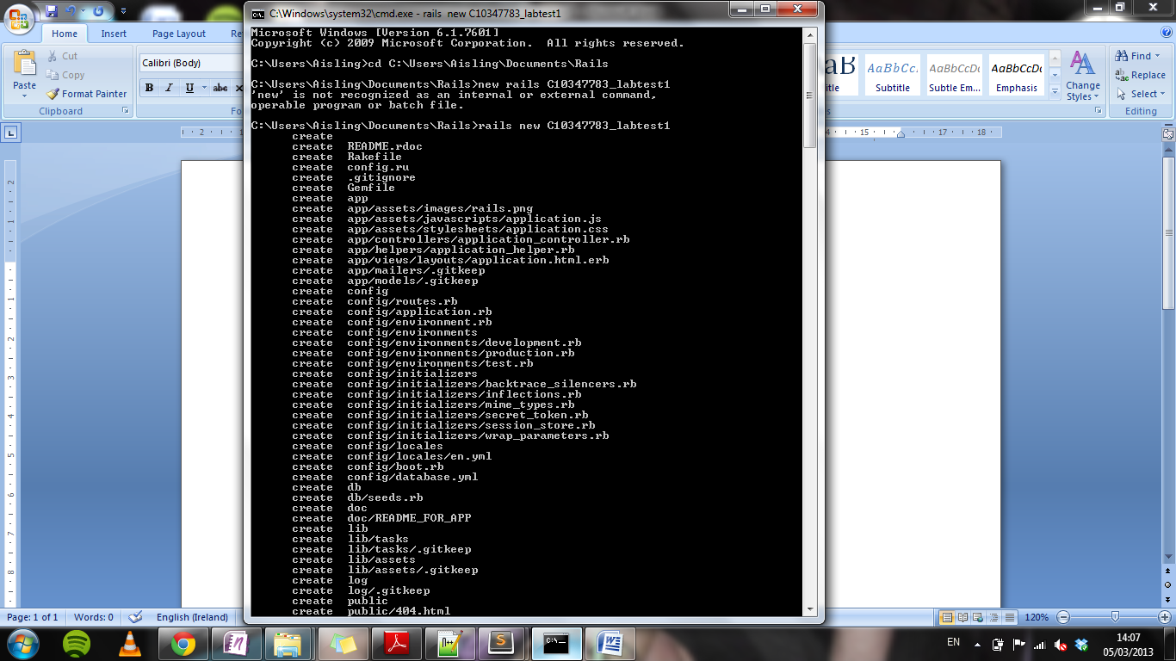

Create controller called MyHome and web page called myIndex

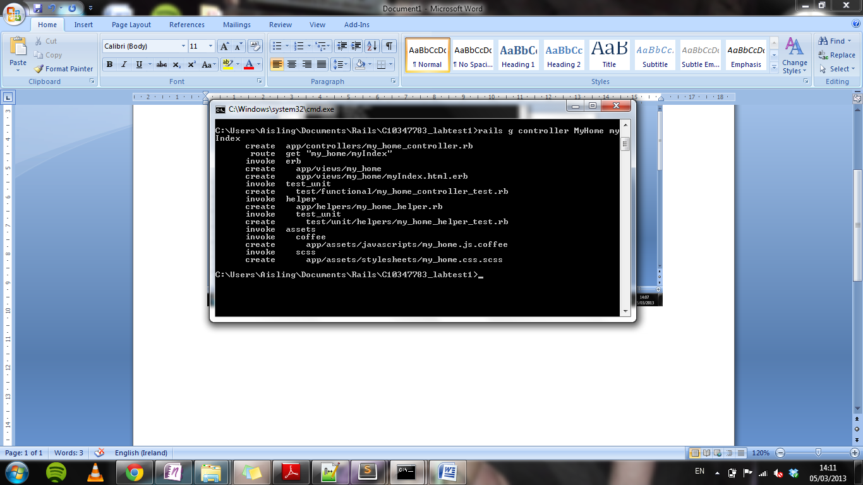

Create controller called MyContacts and web page called myContacts

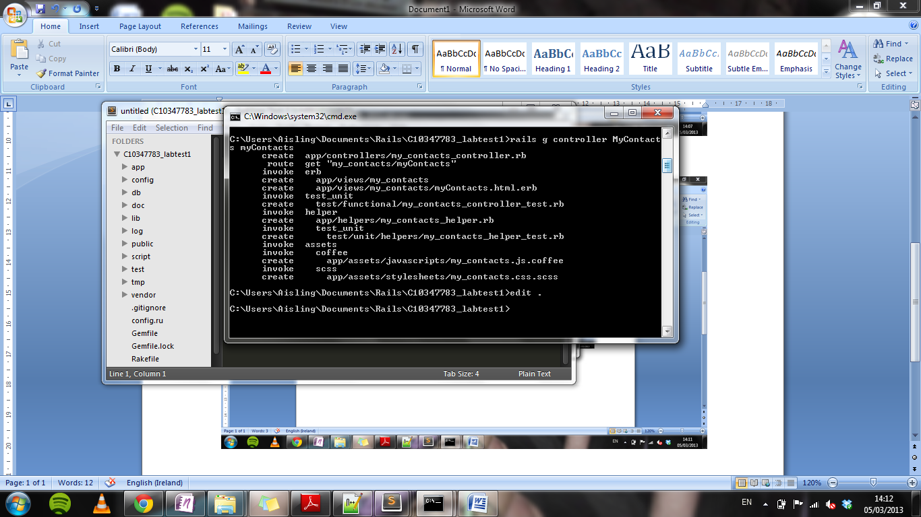

Display myIndex

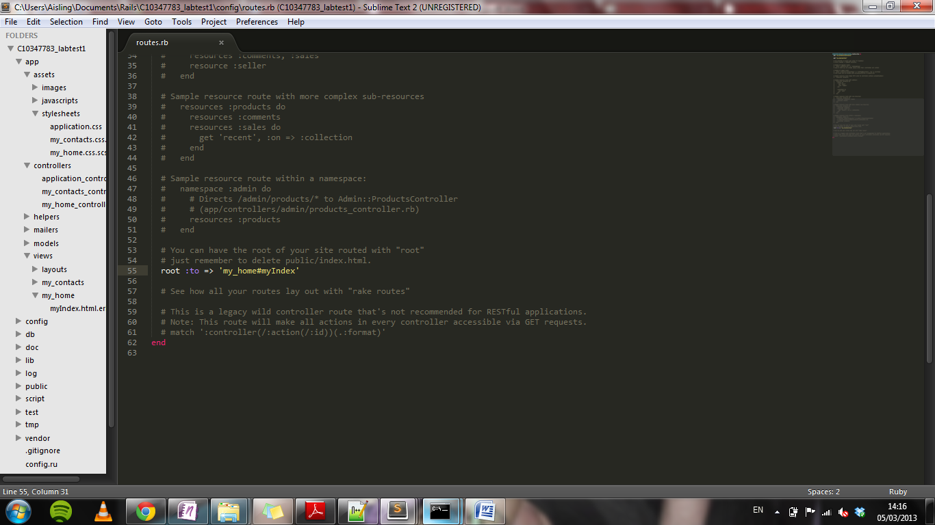

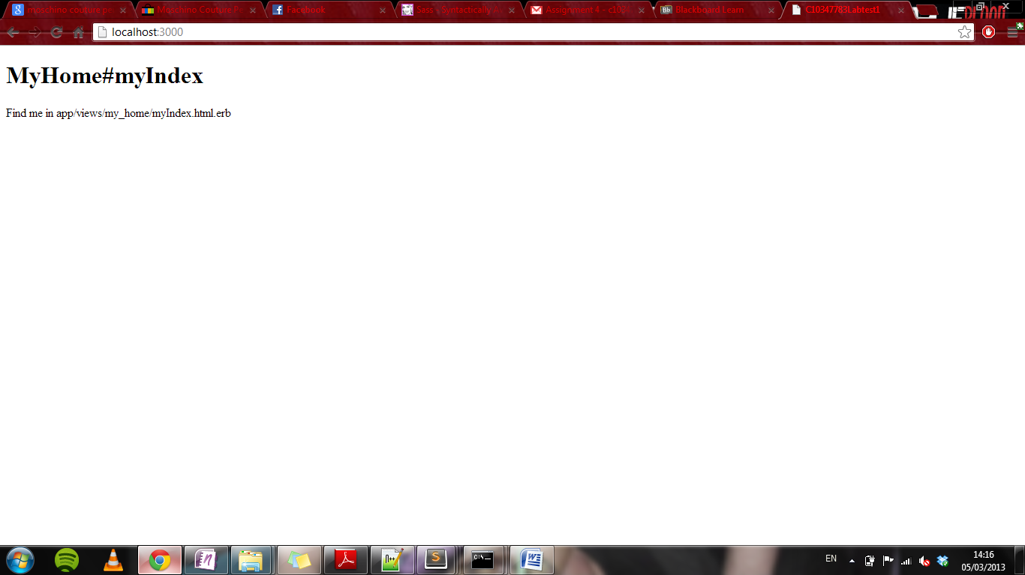

Text at left and right side

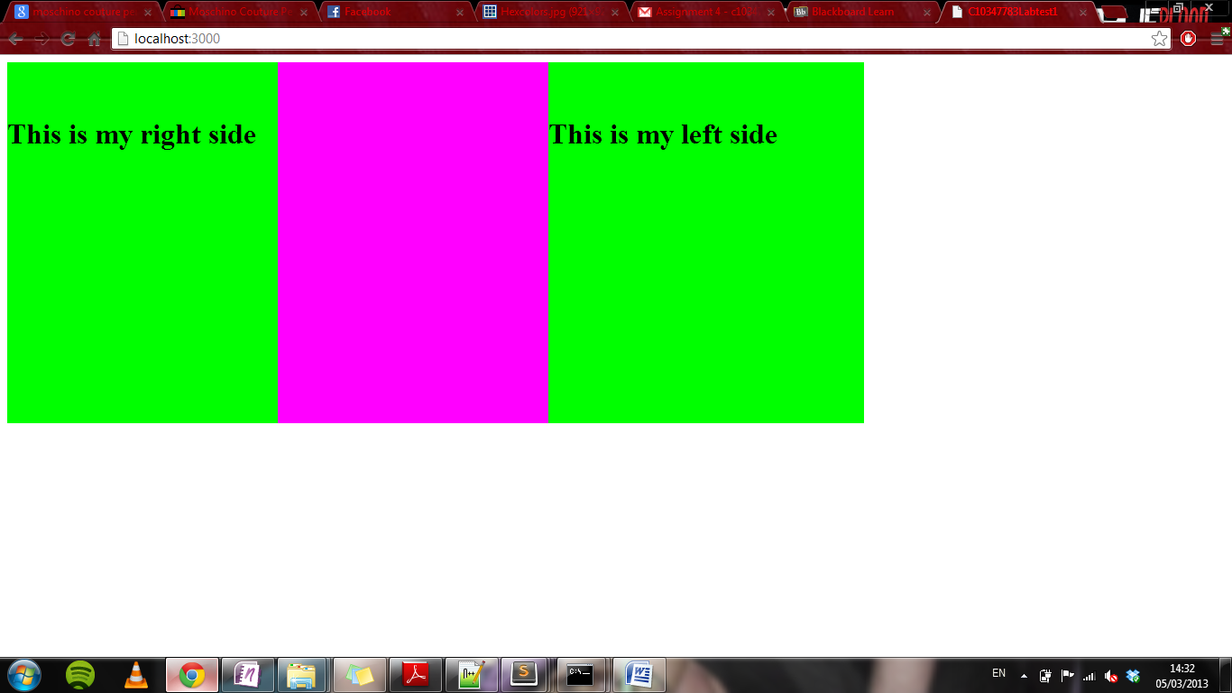

Link myContacts Page

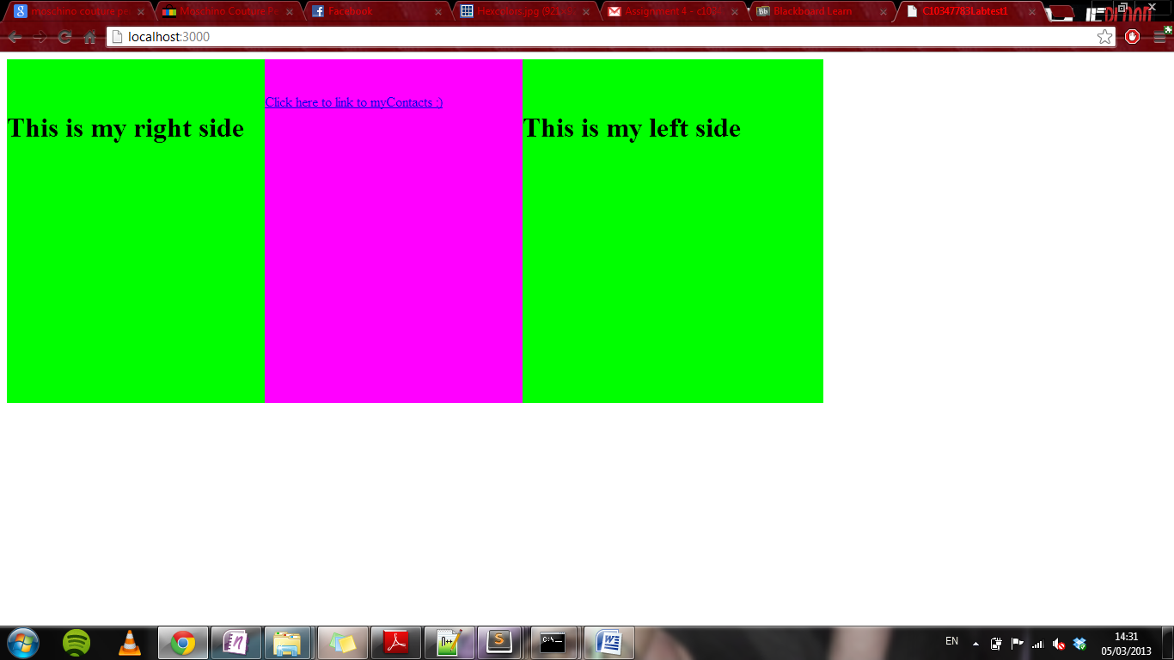

Created a link code in myIndex <% content_for :title, "Column2"%>

<%content_for :col2 do %>

</br></br>

<%= link_to "Click here to link to myContacts :)", my_contacts_path(@my_Contacts) %>

<% end %>

I then added to the routes file

match '/my_contacts' => 'my_contacts#myContacts'